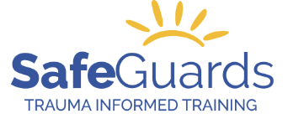
 | ORDER FORM | Date:__________________

Therapeutic Crisis Intervention (TCI) Materials for Certified TCI Trainers
PRODUCT Description | Quantity | Unit Price (Includes shipping & taxes) | Total
TCI Student Workbook, Edition 7 |  | $21.20
TCI Certificates of Attendance, (20 per package) |  | $21.20
TCI Update: Post-Crisis Response, Student Workbooks |  | $21.20
TCI Update: TCI for Developmental Disabilities Student Workbook |  | $21.20
TCI Update: Conflict Resolution |  | $21.20
TCI Update: Adapting the Life Space Interview for Proactive Aggression |  | $21.20
TCI for Families, Student Workbook Fourth Edition |  | $21.20
HST #85526 6979 RT0001 Total
Prices include shipping by overnight Purolator or comparable method.

The new price reflects increased cost of books and shipping

Orders will be processed upon payment.

Payment Method:

o Credit Card: _____Visa _____MasterCard

o Cheque, please send payment to: Safeguards Training for Children & Adult Services

100 York Blvd., Suite 120

Richmond Hill, ON L4B 1J8

Card no.

Expiry date: 3-digit CVV #:

Cardholder name:

SHIPPING INSTRUCTIONS:

Name: Title:
Organization name:
Address:
City: Province: Postal Code:
Phone:
Email address:

SEND TO:
Angela@safeguards-training.net

Please allow 7 days for processing and shipping.
Workbooks to be delivered by:
DD MMM YYYY

