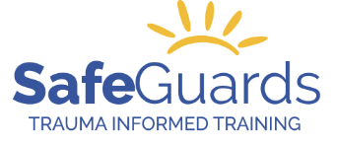
 | ORDER FORM | Date:__________________

Therapeutic Crisis Intervention (TCI) Materials for Certified TCI Trainers
PRODUCT Description | Quantity | Unit Price (Includes shipping & taxes) | Total
TCI Student Workbook, Edition 7 |  | $21.20
TCI Certificates of Attendance, (20 per package) |  | $21.20
TCI Update: Post-Crisis Response, Student Workbooks |  | $21.20
TCI Update: TCI for Developmental Disabilities Student Workbook |  | $21.20
TCI Update: Conflict Resolution |  | $21.20
TCI Update: Adapting the Life Space Interview for Proactive Aggression |  | $21.20
TCI for Families, Student Workbook Fourth Edition |  | $21.20
HST #85526 6979 RT0001 Total
Prices include shipping by overnight Purolator or comparable method.

Orders will be processed upon payment.

Payment Method:

o Credit Card: _____Visa _____MasterCard

o Cheque, please send payment to: Safeguards Training for Children & Adult Services

100 York Blvd., Suite 120

Richmond Hill, ON L4B 1J8

Card no.

Expiry date: 3-digit CVV #:

Cardholder name:

SHIPPING INSTRUCTIONS:

Name: Title:
Organization name:
Address:
City: Province: Postal Code:
Phone:
Email address:

SEND TO:
Registration and Training Events Coordinator Mark (mark@safeguards-training.net)

Please allow 7 days for processing and shipping.
Workbooks to be delivered by:
DD MMM YYYY

